**DAILY ONLINE ACTIVITIES SUMMARY**

|  |  |  |  |  |  |  |  |
| --- | --- | --- | --- | --- | --- | --- | --- |
| **Date:** | **30/05/2020** | | | | **Name:** | **Anusha. K** | |
| **Sem & Sec** | **4th SEM 'A' Section** | | | | **USN:** | **4AL18CS009** | |
| **Online Test Summary** | | | | | | | |
| **Subject** | | 1. **Data communication** 2. **Complex analysis, probability and statistical methods** | | | | | |
| **Max. Marks** | | **30**  **30** | | **Score** | | **27**  **23** | |
| **Certification Course Summary** | | | | | | | |
| **Course** | **Java programming** | | | | | | |
| **Certificate Provider** | | | **greatlearning academy** | **Duration** | | | **3.5 hours** |
| **Coding Challenges** | | | | | | | |
| **Problem statement 1:**  Write a C Program to count Uppercase, Lowercase, special character and numeric values for a given String | | | | | | | |
| **Status: completed** | | | | | | | |
| **Uploaded the report in Github** | | | | **yes** | | | |
| **If yes Repository name** | | | | [**https://github.com/anusha20219/Lockdown-coding**](https://github.com/anusha20219/Lockdown-coding) | | | |
| **Uploaded the report in slack** | | | | **yes** | | | |

**ONLINE TEST DETAILS:** DC test was scheduled from 09:00 am t0 09:45am .The portion for the IA was 3rd and 4th module. there were 30 questions and the time assigned was 45 minutes the questions were mcq type.maths test was scheduled from 3.00 PM to 3.45pm. The questions were mcq type.

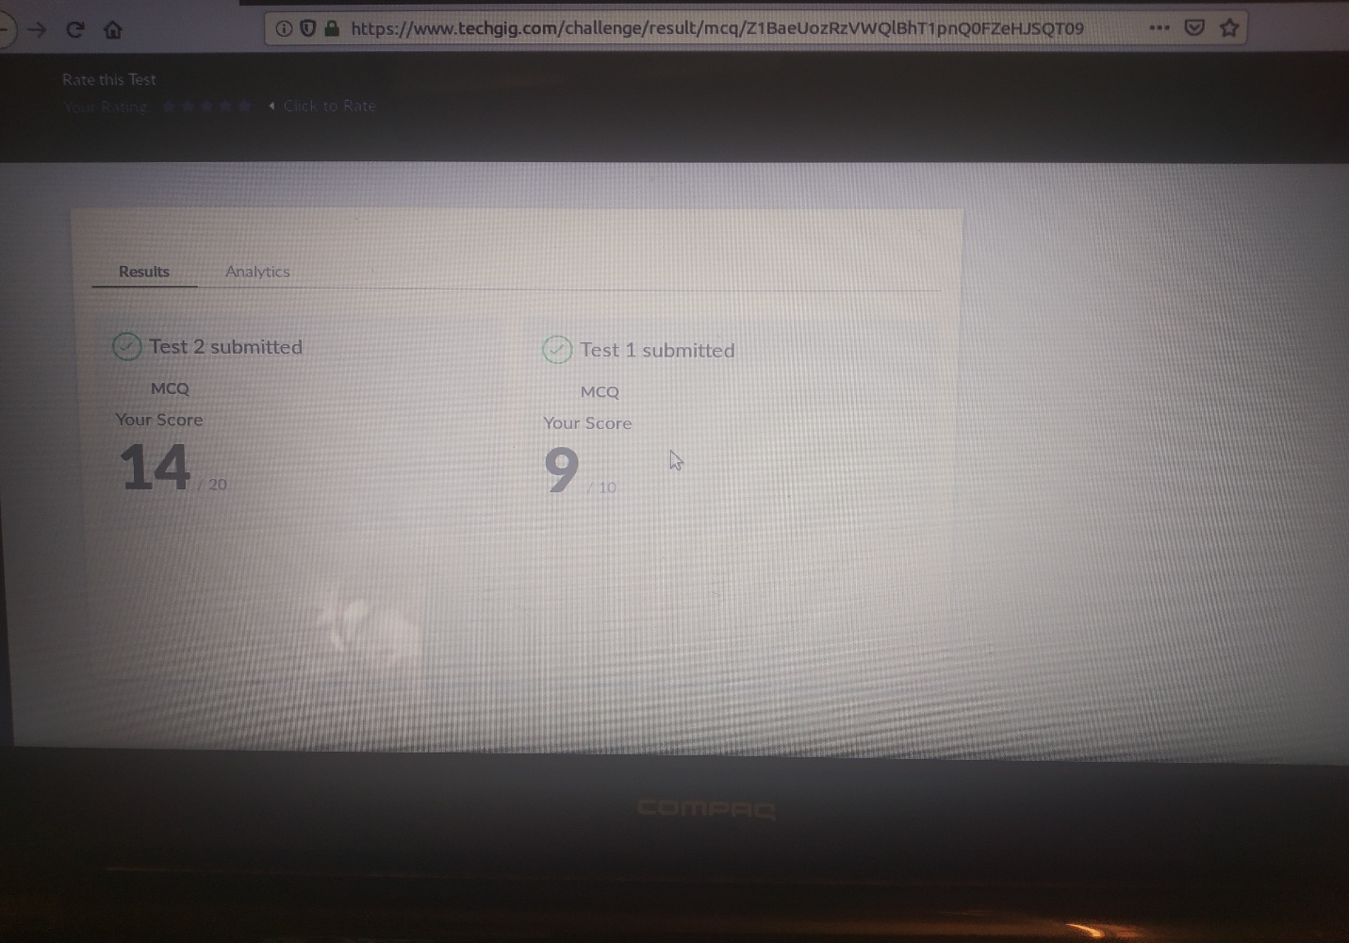

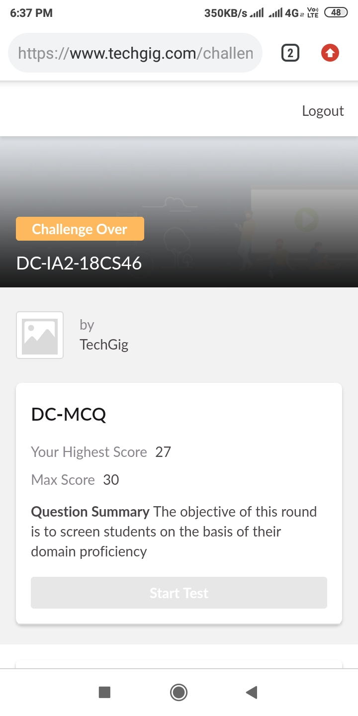

**CERTIFICATION COURSE DETAILS:** Today I studied about which are the operators are there in java and flow control statements in java. Operator in Java is a symbol which is used to perform operations.Logical Operator,Ternary Operator and Assignment Operator. Generally the statements inside your java code are executed from top to bottom, in the order that they appear. Control flow statements, change or break the flow of execution by implementing decision making, looping, and branching your program to execute particular blocks of code based on the conditions.

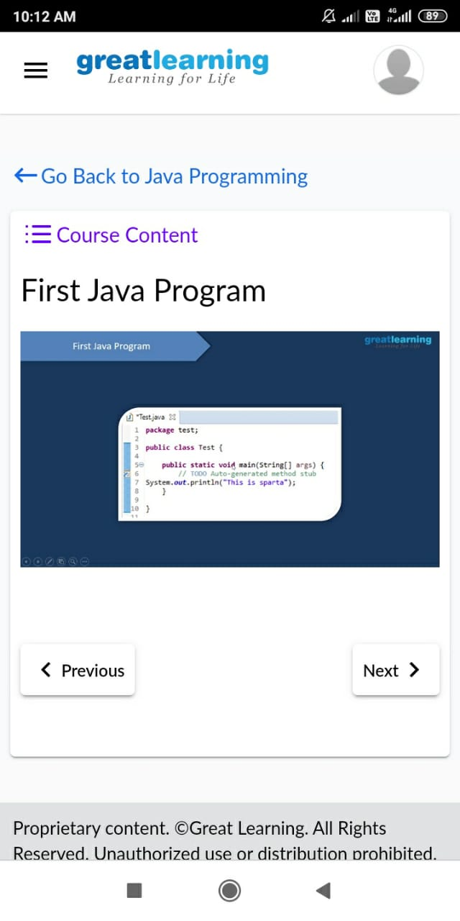

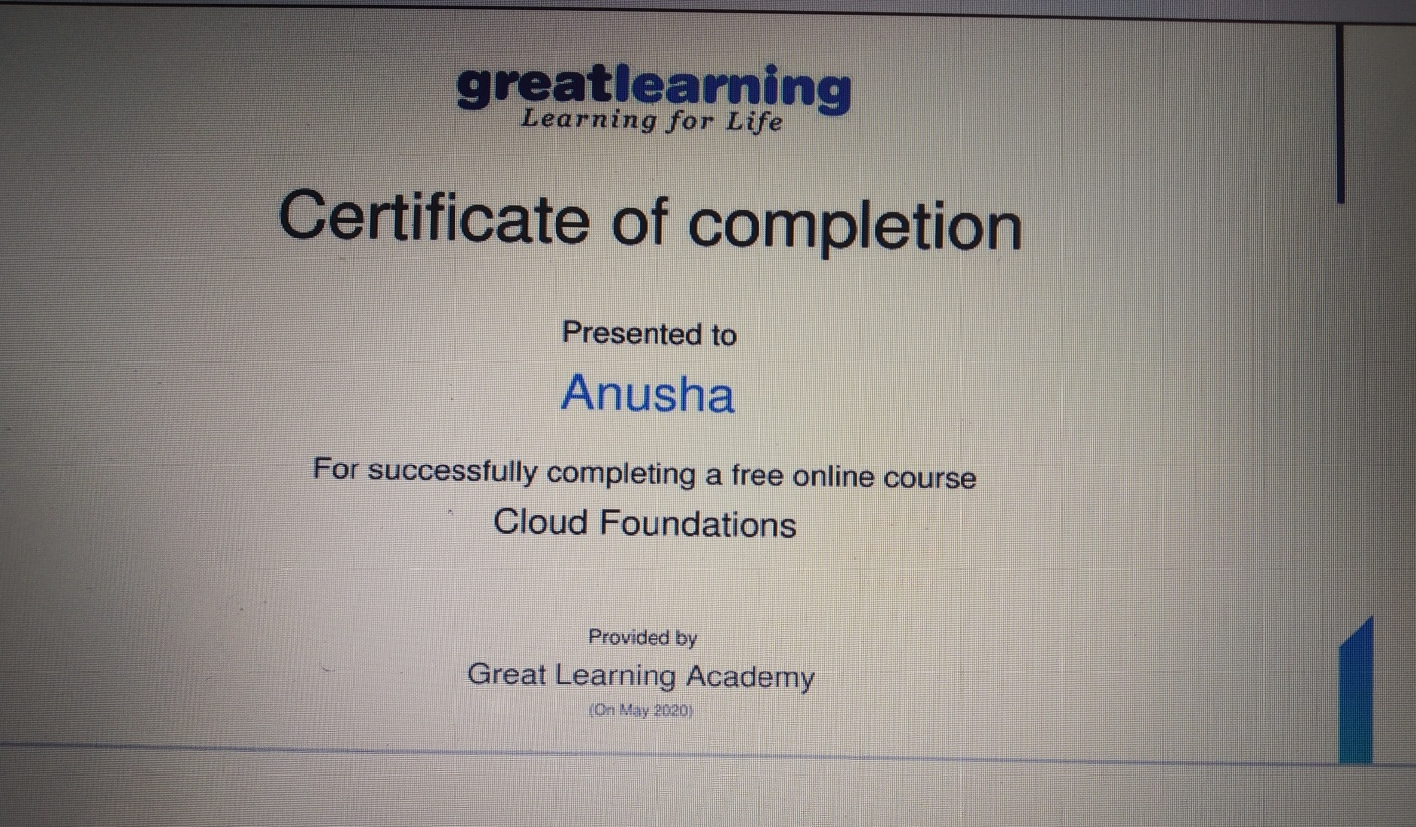Cloud foundations

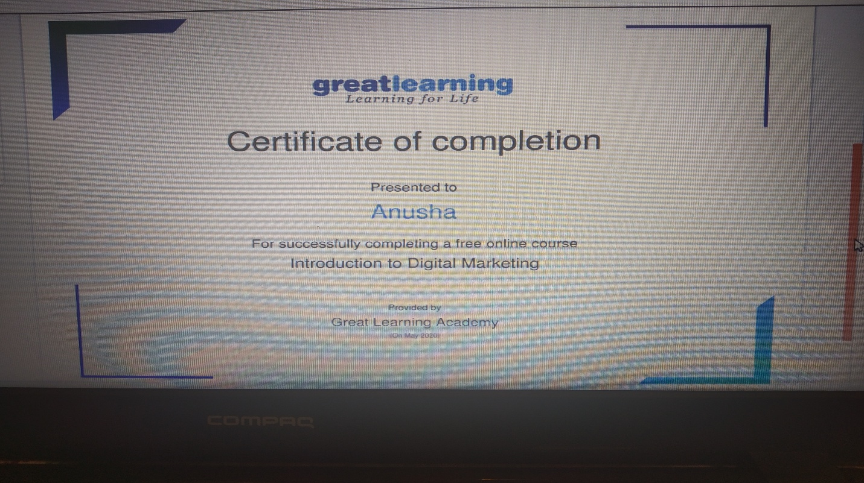

**Introduction to digital marketing**

**Coding challenge details:**

**Problem statement 1:Write a C Program to count Uppercase, Lowercase, special character and numeric values for a given String.**

